|  |  |
| --- | --- |
| ­ | SWINBURNE UNIVERSITY OF TECHNOLOGY  **SCHOOL OF SCIENCE, COMPUTING**  **AND ENGINEERING TECHNOLOGIES**  ===***=== |

**COS10026 COMPUTING TECHNOLOGY INQUIRY PROJECT**

**PROJECT REPORT**

**Assignment Part 2, Semester 1, 2022**

**Server-Side Programming**

**Name: Duy Khoa Pham**

**Student ID: 103515617**

**May 2022**

Table of Contents

1. Introduction 2

1.1 Objective of the report 2

1.2 Outline of report’s structure 2

2. Website 2

2.1 Website introduction 2

2.2 Main user functionalities of the website 2

2.3 Technical details on the website development 4

2.3.1 Markquiz.php 4

2.3.2 Manage.php 5

2.4 Key features 6

2.4.1 Student login and register 6

2.4.2 Admin login and security handler 6

3. Your contribution 7

3.1 Team management 7

3.2 Technical contribution 7

3.3 Solving team’s problems 8

4. Reflection and discussion 8

4.1 Reflections 8

4.2 Discussion 8

5. Conclusion 9

# 1. Introduction

## 1.1 Objective of the report

This report will demonstrate my understanding of the techniques applied while creating the project. Also, in this report, my contribution as a leader will be deeply reflected on and discussed.

## 1.2 Outline of report’s structure

In the beginning, main functionalities, technical details and key features will be demonstrated to provide detailed information about the website. The following section will reiterate through and discuss my contribution to this project. Finally, the report reflects on my personal experience regarding professional purpose and teamwork in this project, as well as suggests some future recommendations.

# 2. Website

## 2.1 Website introduction

This is a full-stack web application scripted in PHP, extending upon the previous HTML and CSS static webpage. It implements database integration to store and update users’ information in a MariaDB database once they have completed the quiz. Additionally, there is a site dedicated to the administrator for management purposes.

## 2.2 Main user functionalities of the website

Before attempting the quiz, users are required to log in or register through our system which is shown in Figure 1. The backend script validates and sanitises input taken from users upon registry and quiz submission. If input from users does not pass the validation check, error messages will be displayed to provide users with detailed insights (Figure 2 – 4).

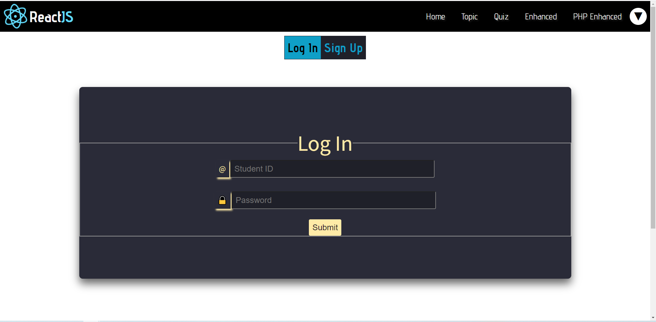

**Figure 1.** Log in/ Sign up interface

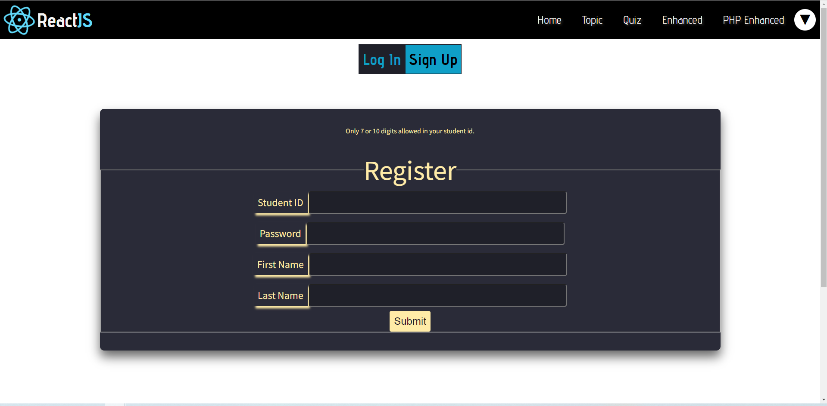

**Figure 2.** An error message of student ID validation

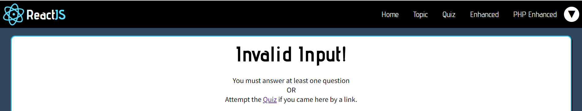

**Figure 3.** Message return on markquiz page if there is no answer from the user

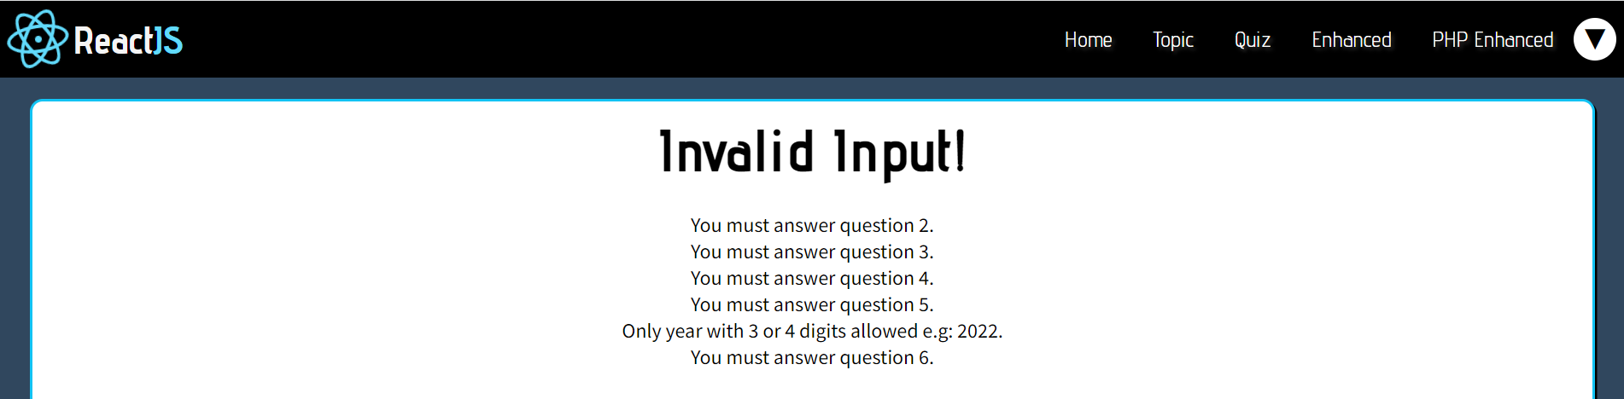

**Figure 4.** Message return on markquiz page if the user does not complete all questions

The website allocates marks to each correct answer and returns the total to users on the “markquiz” page (Figure 5). In addition, users can see their scores, feedback as well as attempted numbers on the “status” page (Figure 6).

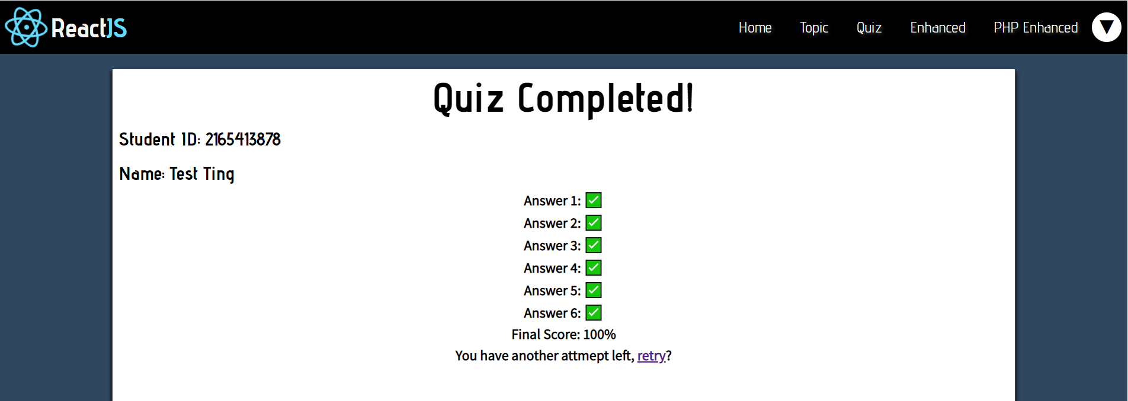

**Figure 5.** The interface when the user answers successfully for first time

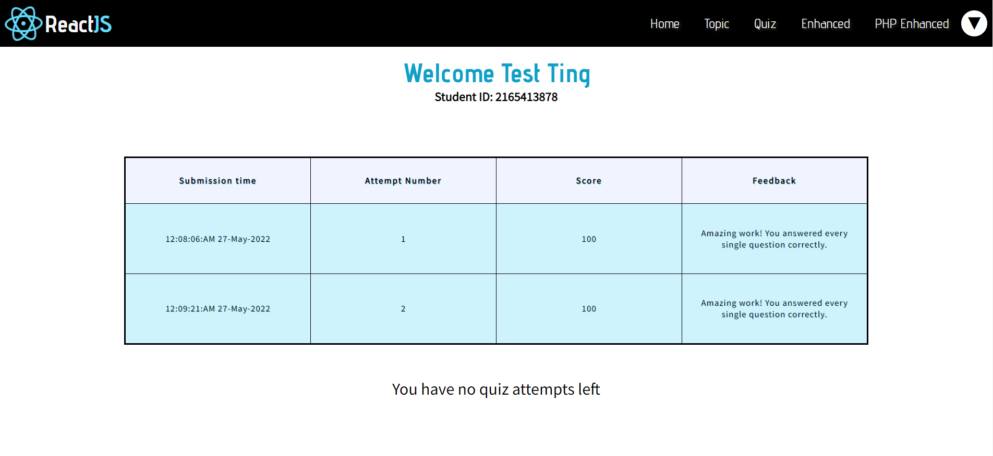

**Figure 6.** Status page

## 2.3 Technical details on the website development

### 2.3.1 Markquiz.php

To validate a quiz attempt, if any question is left unanswered, an empty string will be returned. Afterward, an if/else conditional is utilised to inform users of any missed question. To calculate the number of attempts a user has left, the attempt number is first acquired from the “attempts” table via the query statement: "SELECT ATTEMPT_NUMBER FROM attempts WHERE STUDENT_ID = '$student_id'" and store the query in "$data". A $data value of 0 indicates the user has not taken any attempt and can do the quiz twice. If the user already has one attempt and retakes the quiz, we insert into the table information on their second attempt. If they already have 2 attempts, the team redirects them to the “checkattempts” page and does not allow them to do any more quizzes (Figure 7).

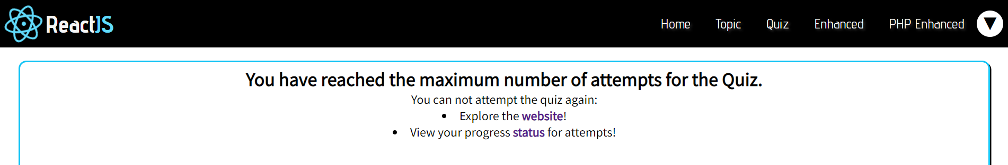

**Figure 7.** User is moved to checkattemtps when having 2 attempts

### 2.3.2 Manage.php

For the search functionality, by using “LIKE '%$search%'”, the team creates a strong search engine, capable of locating an account from any subset of characters provided. Additionally, the administrator can find users by searching for their whole name or student ID. To delete a student’s information from the table, the query “DELETE FROM” is used with the filter WHERE “$studentID = $delete”. The "UPDATE" query statement is used to update the old score from an administrator-supplied pair of student ID and attempt number (Figure 8). To sort retrieved results, we select all information, extend the original query with an “ORDER BY” customised with a supervisor-specified column and direction, then perform the query again and display the newly sorted results which are shown in Figure 9.

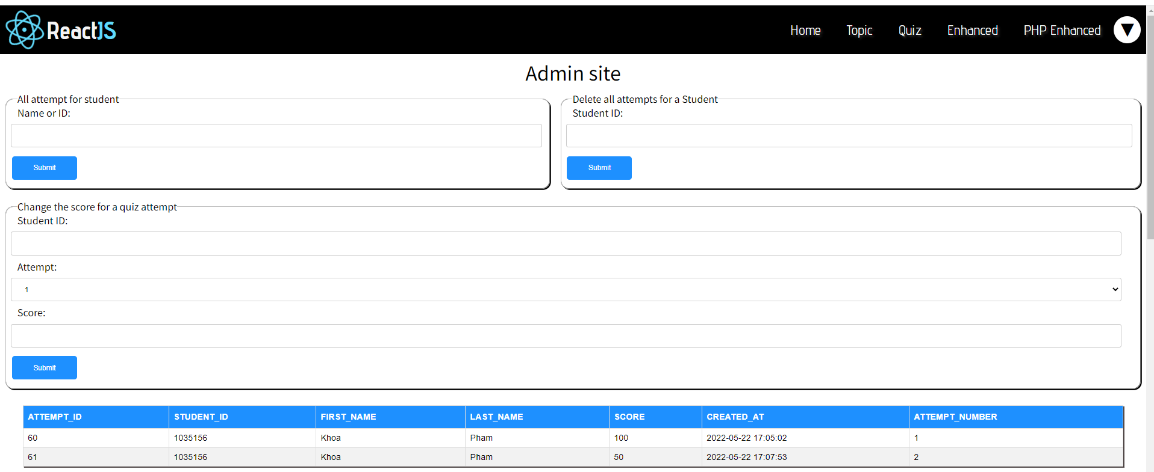

**Figure 8.** Manage interface when changing score of student ID

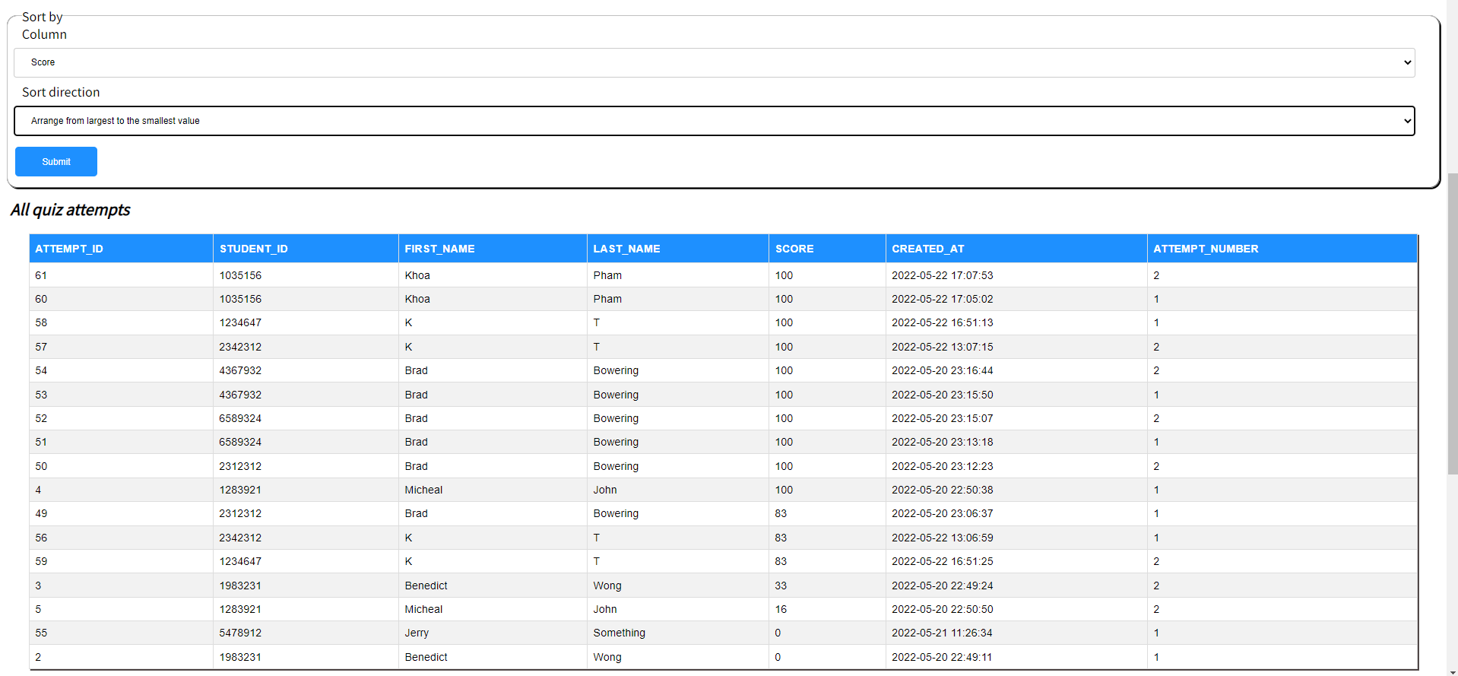

**Figure 9.** Sorting scores from largest to smallest

## 2.4 Key features

### 2.4.1 Student login and register

The system requires users to register before doing the quiz; therefore, each user only has one consistent account linked to their first name, last name, and ID. In particular, when a user registers, if their student ID does not already exist in the “students” table, their information will be stored there. Upon a login attempt, the student ID and password are compared to authenticate the account via a “SELECT” query. Moreover, a primary-foreign key relationship between “attempts” and “students” tables is implemented to interlink their relevant data.

### 2.4.2 Admin login and security handler

To enable better security, the team creates a “logSecurity” table to store all login attempts for each username in an “admin” table. If the attempt time exceeds 3, this account will be locked. Even if the admin type correct username and password, they still cannot log in into “manage” page which is shown in Figure 10. This locking mechanism remains in 300 seconds and this time of period, the username and attempt time will no longer in “logSecurity” table, so the admin is able to log in again.

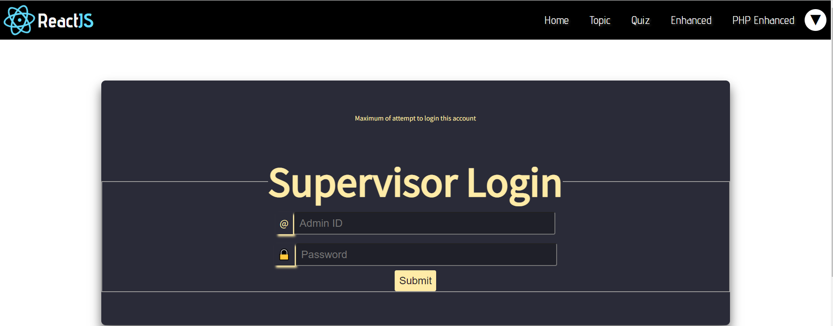

**Figure 10.** Supervisor Login interface when having three or more invalid login attempts

# 3. Your contribution

## 3.1 Team management

First and foremost, as the leader of the team, I encourage participation via personal communication with each member to facilitate enthusiasm for the project. I estimated the workload of this project, then approximated the time and effort dedication this project would require. That preparation allows me to be an efficient goal setter, setting weekly objectives and progress expectations early on in the development cycle. From those goals, I divide requirement checklists to allocate tasks to every member based on their strength and time contribution. Furthermore, I document meeting minutes to update, assign tasks, keep the team in line and ensure progress remains on track. A GitHub source-control is established to formalise version control and ensure best programming practices are followed similar to a professional production environment. A Discord server is established as our main channel of communication, centralizing our communication regarding deadlines or meetings and providing a historical log for retrospective inspection.

## 3.2 Technical contribution

As for technical aspects, I am in charge of creating the “markquiz” page, validation functions, “attempts” table and primary-foreign key enhancement. Particularly, I have coded most parts of “markquiz” and validation functions for the registration site. Afterward, for testing purposes, I created a sheet (Figure 11) to list all possible mistakes and assign test cases to members of the group. This acts as a precursor to the testing progress as it allows timely error tracing. The debugging process is significantly simplified as troubleshooting tasks are allocated to people in charge of a particular site’s development (for me it is markquiz and validation).

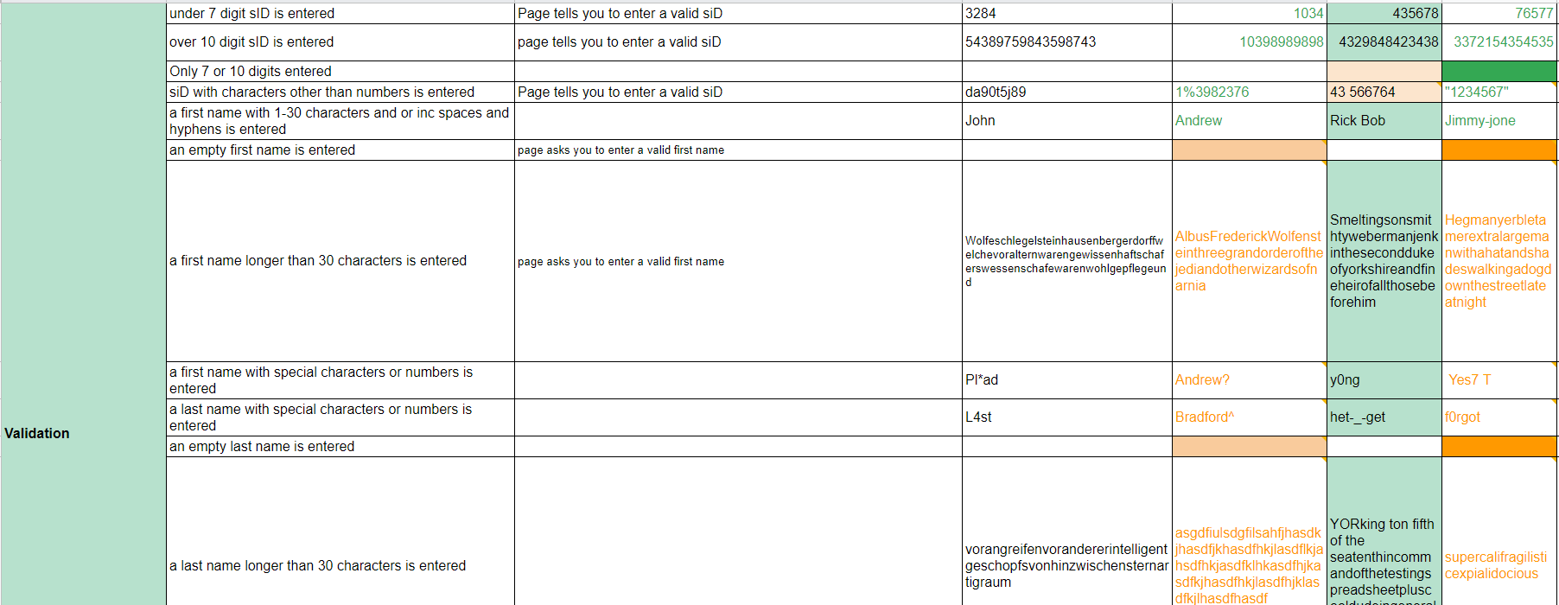

**Figure 11.** Validation part of testing sheet

## 3.3 Solving team’s problems

Upon any conflict, I would take on the role of the pacifier to help de-escalate the issue and help everyone reach a compromise from a rational standpoint. I am the team’s primary contact with the tutor, bringing attention to our queries and resolving any uncertainties emerging in the process. I flexibly assuage my teammates’ concerns and identify solutions that would best appease everyone to a reasonable degree. I maintain a democracy and decentralization of influence among members via adhering to best leadership principles, one of which dictates transparency in any and all decisions reached. When a member is lacking behind, I provide the necessary incentive to help narrow the gap and offer them an opportunity to catch up. In the presentation video, I based each member’s knowledge and skill level to split the spoken script and ensure each member gets an equal part in the final product. I planned the video structure and identified the sections required, then delegated the task to another member for media production.

# 4. Reflection and discussion

## 4.1 Reflections

Regarding professional purpose, thanks to this project, I have gained a closer insight into the operation of a development team involved in source control, in the process improving my teamwork skills. My own understanding on my personal values and potential contribution to present or future assignment is explored in further depth. Besides, from previous experience acquired from assignment 1, to narrow down the level gap between member capabilities, I required all members to read and follow lab 8 to lab 10 beforehand. Subsequently every member is appropriately knowledgeable to an extent they can function as an effective teammate, actively contributing to the website.

## 4.2 Discussion

Since this is the first project with web development, mistakes are inevitable especially, regarding the security of user accounts. In a similar future project, when registering, users need to give more detailed information including their emails. The team sends an activating email ensuring that their details are correct. Thanks to that, if they forget or their account is stolen, the team will create a reset password function; therefore; users are able to reset their new password through email. As for team management, I will make use of supportive tools like Trello to aid in tasks assigned to members. Therefore, everyone can easily keep track of the project’s progress and create a more professional environment.

# 5. Conclusion

Throughout the project, the team has been given the chance to acquire basic knowledge of PHP and MySQL covered in the unit as well as some more advanced topics accumulated in our research during the development of the webpage’s backend. This report went over the highlights of technical and management processes during this assignment, elaborating on details whenever necessary to demonstrate a profound understanding of the introduced concepts. Furthermore, this project is an invaluable hands-on experience to give us direct practice applying learnt theory on a real-life and multicultural project.